The holiday lights are down, the shiny red bows have been packed away, and we find ourselves left with the drab winter landscape that will surround us until spring. January brings the promise of a new and better year, but the central Ohio landscape is not exactly a reflection of our inner sense of hope and rejuvenation! Although it may not be possible to experience the pastel flowers of spring, the brightly colored butterflies of summer, or the blazing reds of fall in our “Great Outdoors” at this time of year, winter need not be as bland and colorless as you may think.
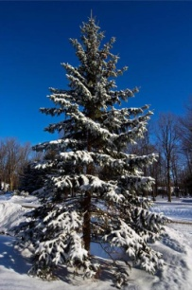
The first plants that come to mind when people think of the winter landscape are Pine Trees, Spruce Trees, and Holly Shrubs. Along with Boxwoods, Yews/Taxus, Arborvitaes, and Junipers, these plants represent “the old stand-bys” for winter interest. Evergreen trees and shrubs are an important component of any planting plan because they provide structure and weight to your landscape all year long. Often overlooked during the summer, evergreen trees and shrubs deliver a nice splash of color during the winter when we primarily see a landscape of browns and grays. Many groundcovers, such as English Ivy and Vinca, are also evergreen and provide a lush green carpet where there would otherwise be an empty mulch bed.
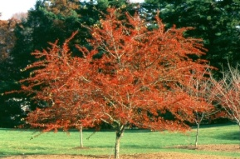
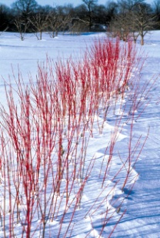
Although any discussion of winter landscape interest must begin with evergreens, it most definitely should not end there. One of the most popular plants with distinct winter interest plant is the Red Twig Dogwood shrub. As the weather gets colder you will notice the brown branches beginning to turn red, with the newest stems having the most vibrant color. Varieties of this plant boast colorful stems ranging from bright red to orange-red to coral red. Another interesting selection is the Red Twig Dogwood’s cousin, the Yellow Twig Dogwood. The bright stems of the Red Twig and Yellow Twig Dogwood especially pop when planted in mass and surrounded by a blanket of fresh snow!
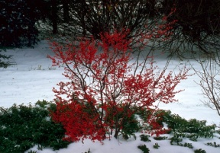
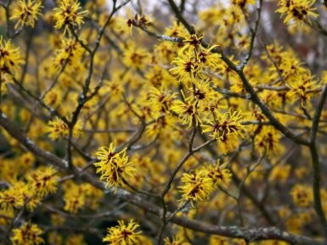
Planting trees and shrubs that maintain their berries throughout the winter is another way to add color to your winter landscape. The familiar Blue Holly has a deciduous relative, Winterberry Holly, which retains clusters of bright red berries on bare branches throughout the winter. The Winter King Hawthorn is a great ornamental tree that also has persistent red berries in the winter. The berries can be especially striking when viewed against a backdrop of Spruce trees! One winter flowering plant that should not be overlooked is the Vernal Witch-hazel shrub. During the warm days of January and February you may notice these plants unfurling small clusters of orange or yellow spider-like petals. Like us humans on cold days, you may also notice that these petals curl up when the temperature drops. This survival technique helps the flowers to persist until March or April.
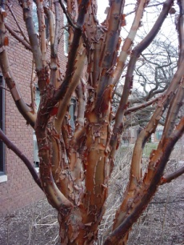
Interesting textures are another way that you can add interest to you winter landscape. The exfoliating bark of Oakleaf Hydrangeas, Paperbark Maples, and London Planetrees can be very eye catching at a time when there are fewer colors around to distract from this unusual feature. The exposed white bark of the London Plantree can be especially striking on a night illuminated by a full moon! The dried flower heads of Hydrangea shrubs and seed heads of a variety of Ornamental Grasses add another attractive texture to the winter scenery. An additional interesting plant selection is Harry Lauder’s Walking Stick. The distinctive twisty curlicue branches of this shrub make it a unique standout year-round, but especially in the winter when the leaves have dropped and the branching pattern is on full display.
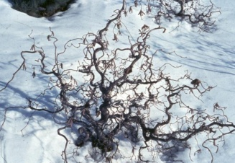
Winter may not be the most colorful time of year, but your “Great Outdoors” need not be drab and boring. The strategic use of a few plants that provide a burst of color or interesting texture can make your landscape really pop and stand out from the rest. A few splashes of interest can be a reminder that spring is just around the corner, and that may be just what you need to help you endure the rest of the winter!

